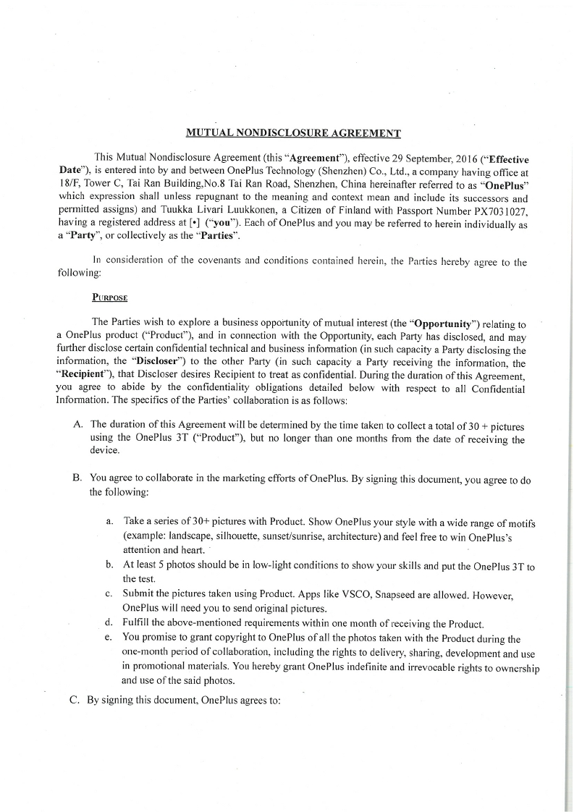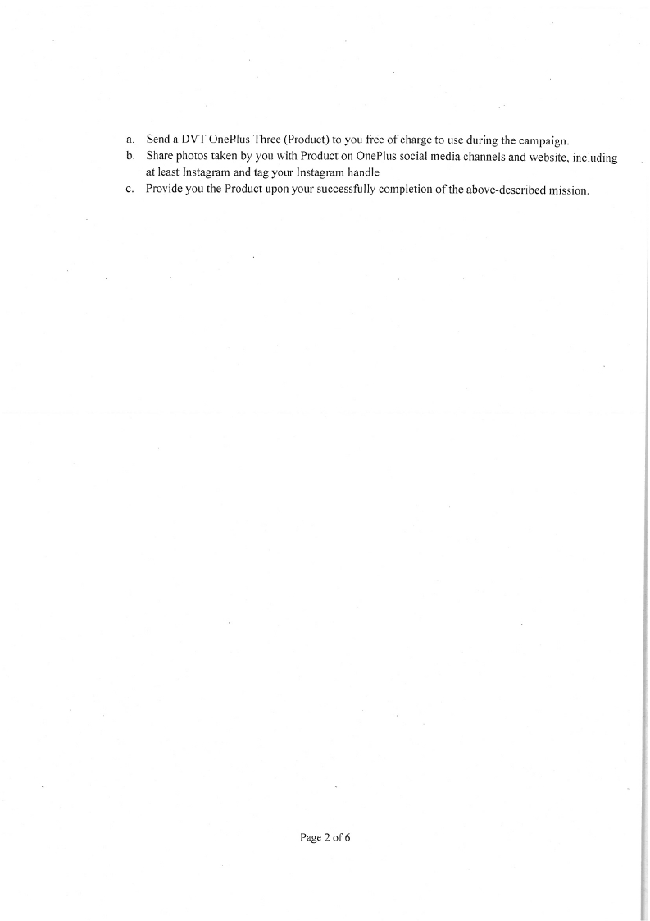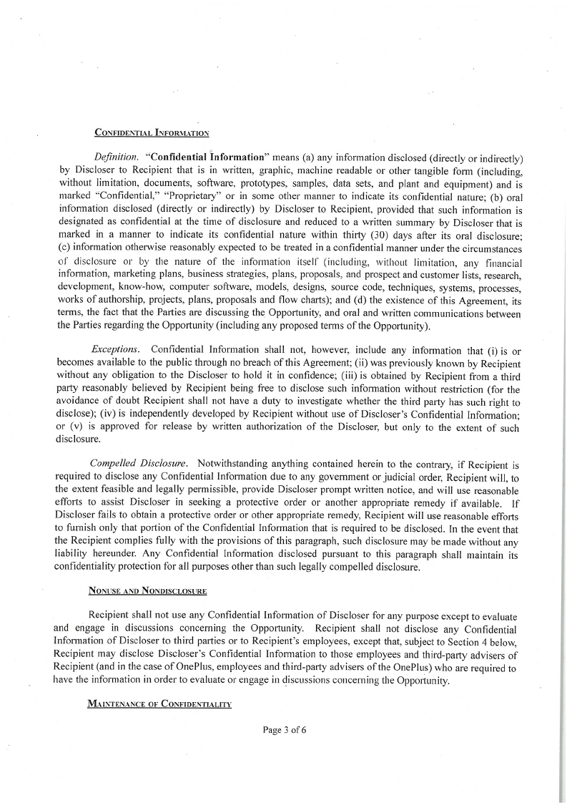

**Thank you for using iskysoft PDF Editor.**



**You can only convert up to 5 pages in the trial version.**

**To get the full version,please purchase the program here:**

[*http://cbs.iskysoft.com/go.php?pid=1273&m=db*](http://cbs.iskysoft.com/go.php?pid=1273&m=db)